

**Time Series Forecasting - Business Report**

**By: Aaryani Kadiyala**

**PGP-Data Science and Business Analytics**

**(PGPDSBA.O.JAN24.A)**

**Table of Contents**

1. Problem ----------------------------------------------------------------------------------------------------------------------- 5

**List of Tables:**

Table 1: Rose Wine Forecast for next 12 months - 2 point Moving Average ------------------------------------------- 41

Table 2: Rose Wine Forecast - next 12 months - Triple Exponential Smoothing – Additive ------------------------ 42

Table 3: Sparkling Wine Forecast - next 12 months - Triple Exponential Smoothing – Additive ------------------- 44

**List of Figures:**

Figure 1: Head of Rose Wine -------------------------------------------------------------------------------------------------------- 6

Figure 2: Head of Sparkling Wine -------------------------------------------------------------------------------------------------- 6

Figure 3: Head of Rose Wine after conversion ---------------------------------------------------------------------------------- 7

Figure 4: Head of Sparkling Wine after conversion ---------------------------------------------------------------------------- 7

Figure 5: Rose Wine Plot on Original Data --------------------------------------------------------------------------------------- 7

Figure 6: Sparkling Wine Plot on Original Data ---------------------------------------------------------------------------------- 7

Figure 7: Yearly Production of Rose Wine ---------------------------------------------------------------------------------------- 8

Figure 8: Yearly Production of Sparkling Wine ---------------------------------------------------------------------------------- 8

Figure 9: Monthly Sales Across years for Rose Wine -------------------------------------------------------------------------- 9

Figure 10: Monthly Production of Rose Wine ---------------------------------------------------------------------------------- 10

Figure 11: Monthly Sales Across years for Sparkling Wine ------------------------------------------------------------------ 10

Figure 12: Monthly Production of Sparkling Wine ---------------------------------------------------------------------------- 11

Figure 13: Quarterly Production of Rose Wine --------------------------------------------------------------------------------- 11

Figure 14: Quarterly Production of Sparkling Wine --------------------------------------------------------------------------- 12

Figure 15: Additive Decomposition of Rose Wine ----------------------------------------------------------------------------- 13

Figure 16: Additive Decomposition of Sparkling Wine ----------------------------------------------------------------------- 13

Figure 17: Multiplicative Decomposition of Rose Wine ---------------------------------------------------------------------- 14

Figure 18: Multiplicative Decomposition of Sparkling Wine ---------------------------------------------------------------- 14

Figure 19: Train & Test Split of Rose Wine ------------------------------------------------------------------------------------- 15

Figure 20: Train & Test Split of Sparkling Wine ------------------------------------------------------------------------------- 15

Figure 21: Train & Test Set of Rose Wine ---------------------------------------------------------------------------------------- 16

Figure 22: Train & Test Set of Sparkling Wine ---------------------------------------------------------------------------------- 16

Figure 23: Linear Regression of Rose Wine ------------------------------------------------------------------------------------- 17

Figure 24: Linear Regression of Sparkling Wine -------------------------------------------------------------------------------- 17

Figure 25: Simple Average of Rose Wine ---------------------------------------------------------------------------------------- 18

Figure 26: Simple Average of Sparkling Wine ---------------------------------------------------------------------------------- 18

Figure 27: Moving Average of Rose Wine --------------------------------------------------------------------------------------- 19

Figure 28: Moving Average of Sparkling Wine --------------------------------------------------------------------------------- 19

Figure 29: Test RSME of all 3 models of Rose & Sparkling Wine ----------------------------------------------------------- 20

Figure 30: Simple Exponential Smoothing of Rose Wine -------------------------------------------------------------------- 21

Figure 31: Simple Exponential Smoothing of Sparkling Wine -------------------------------------------------------------- 21

Figure 32: Double Exponential Smoothing of Rose Wine -------------------------------------------------------------------- 22

Figure 33: Double Exponential Smoothing of Sparkling Wine -------------------------------------------------------------- 22

Figure 34: Triple Exponential Smoothing of Rose Wine – Additive ------------------------------------------------------- 23

Figure 35: Triple Exponential Smoothing of Sparkling Wine – Additive -------------------------------------------------- 23

Figure 36: Triple Exponential Smoothing of Rose Wine – Multiplicative ------------------------------------------------ 24

Figure 37: Triple Exponential Smoothing of Sparkling Wine – Multiplicative ------------------------------------------ 24

Figure 38: Test RSME of all models of Rose Wine ----------------------------------------------------------------------------- 25

Figure 39: Test RSME of all models of Sparkling Wine ----------------------------------------------------------------------- 25

Figure 40: Stationary of Rose Wine ----------------------------------------------------------------------------------------------- 27

Figure 41: Stationary of Sparkling Wine ----------------------------------------------------------------------------------------- 28

Figure 42: ACF of Auto ARIMA of Rose Wine ----------------------------------------------------------------------------------- 29

Figure 43: PACF of Auto ARIMA of Rose Wine --------------------------------------------------------------------------------- 29

Figure 44: ACF of Auto ARIMA of Sparkling Wine ----------------------------------------------------------------------------- 30

Figure 45: PACF of Auto ARIMA of Sparkling Wine --------------------------------------------------------------------------- 30

Figure 46: Model Combinations of Rose & Sparkling Wine ----------------------------------------------------------------- 31

Figure 47: Auto ARIMA of Rose Wine -------------------------------------------------------------------------------------------- 31

Figure 48: Diagnostic Plot of Auto ARIMA of Rose Wine -------------------------------------------------------------------- 32

Figure 49: Auto ARIMA of Sparkling Wine --------------------------------------------------------------------------------------- 32

Figure 50: Diagnostic Plot of Auto ARIMA of Sparkling Wine --------------------------------------------------------------- 33

Figure 51: Manual ARIMA of Rose Wine ----------------------------------------------------------------------------------------- 33

Figure 52: Diagnostic Plot of Manual ARIMA of Rose Wine ----------------------------------------------------------------- 34

Figure 53: Manual ARIMA of Sparkling Wine ----------------------------------------------------------------------------------- 34

Figure 54: Diagnostic Plot of Manual ARIMA of Sparkling Wine ----------------------------------------------------------- 35

Figure 55: Model Combinations of Rose & Sparkling Wine ----------------------------------------------------------------- 35

Figure 56: Diagnostic Plot of Auto SARIMA of Rose Wine – (1,1,1) (2,0,3,6) ------------------------------------------- 36

Figure 57: Diagnostic Plot of Auto SARIMA of Rose Wine – (1,1,2)) (2,0,2,12) ----------------------------------------- 36

Figure 58: Diagnostic Plot of Auto SARIMA of Sparkling Wine – (0,1,1)) (2,0,2,6) ------------------------------------- 37

Figure 59: Diagnostic Plot of Auto SARIMA of Sparkling Wine – (1,1,2)) (2,0,2,12) ----------------------------------- 37

Figure 60: Diagnostic Plot of Manual SARIMA of Rose Wine – (0,1,0) (1,1,3,6) --------------------------------------- 38

Figure 61: Diagnostic Plot of Manual SARIMA of Rose Wine – (2,1,2) (2,1,2,12) -------------------------------------- 38

Figure 62: Diagnostic Plot of Manual SARIMA of Sparkling Wine – (0,1,0) (1,1,3,6) ---------------------------------- 39

Figure 63: Diagnostic Plot of Manual SARIMA of Sparkling Wine – (2,1,2) (2,1,2,12) -------------------------------- 39

Figure 64: RSME Values of Rose Wine in Ascending Order ----------------------------------------------------------------- 40

Figure 65: Rose Wine Forecast for next 12 months - 2 point Moving Average ---------------------------------------- 41

Figure 66: Rose Wine Forecast - next 12 months - Triple Exponential Smoothing – Additive --------------------- 42

Figure 67: RSME Values of Sparkling Wine in Ascending Order ------------------------------------------------------------ 43

Figure 68: Sparkling Wine Forecast - next 12 months - Triple Exponential Smoothing – Additive ---------------- 44

Figure 69: Monthly Sales of Rose Wine ------------------------------------------------------------------------------------------ 45

Figure 70: Monthly Sales of Sparkling Wine ------------------------------------------------------------------------------------ 46

**Problem Statment :**

### **Context**

### As an analyst at ABC Estate Wines, we are presented with historical data encompassing the sales of different types of wines throughout the 20th century. These datasets originate from the same company but represent sales figures for distinct wine varieties. Our objective is to delve into the data, analyze trends, patterns, and factors influencing wine sales over the course of the century. By leveraging data analytics and forecasting techniques, we aim to gain actionable insights that can inform strategic decision-making and optimize sales strategies for the future.

### **Objective**

### The primary objective of this project is to analyze and forecast wine sales trends for the 20th century based on historical data provided by ABC Estate Wines. We aim to equip ABC Estate Wines with the necessary insights and foresight to enhance sales performance, capitalize on emerging market opportunities, and maintain a competitive edge in the wine industry.

**Solution :**

### **Rose Wine:**

### **Synopsis:**

* Total no. of Entries = 187
* No. of Null Value = 2
* No Duplicates
* Train Set split till 1990 & Test set from 1991.
* Forecasting Models used
  + Linear Regression
  + Simple Average
  + 2 Point Moving Average
  + 4 Point Moving Average
  + 6 Point Moving Average
  + 9 Point Moving Average
  + Single Exponential Smoothing
  + Double Exponential Smoothing (Holt’s Model)
  + Triple Exponential Smoothing (Holt-Winter Model) – Additive Model
  + Triple Exponential Smoothing (Holt-Winter Model) – Multiplicative Model
  + ARIMA / SARIMA (Auto fitted)
  + ARIMA / SARIMA (Manually fitted)

**Sparkling Wine:**

**Synopsis:**

* Total no. of Entries = 187
* No Null values
* No Duplicates
* Train Set split till 1990 & Test set from 1991.
* Forecasting Models used
  + Linear Regression
  + Simple Average
  + 2 Point Moving Average
  + 4 Point Moving Average
  + 6 Point Moving Average
  + 9 Point Moving Average
  + Single Exponential Smoothing
  + Double Exponential Smoothing (Holt’s Model)
  + Triple Exponential Smoothing (Holt-Winter Model) – Additive Model
  + Triple Exponential Smoothing (Holt-Winter Model) – Multiplicative Model
  + ARIMA / SARIMA (Auto fitted)
  + ARIMA / SARIMA (Manually fitted)

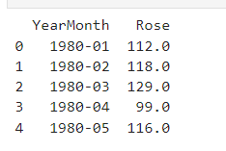 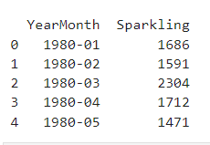

Figure 1: Head of Rose Wine Figure 2: Head of Sparkling Wine

Converted ‘YearMonth’ Column of both Rose & Sparkling wine into datetime.

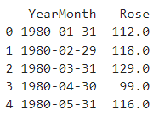 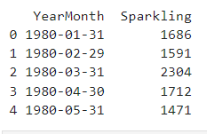

Figure 3: Head of Rose Wine after conversion Figure 4: Head of Sparkling Wine after conversion

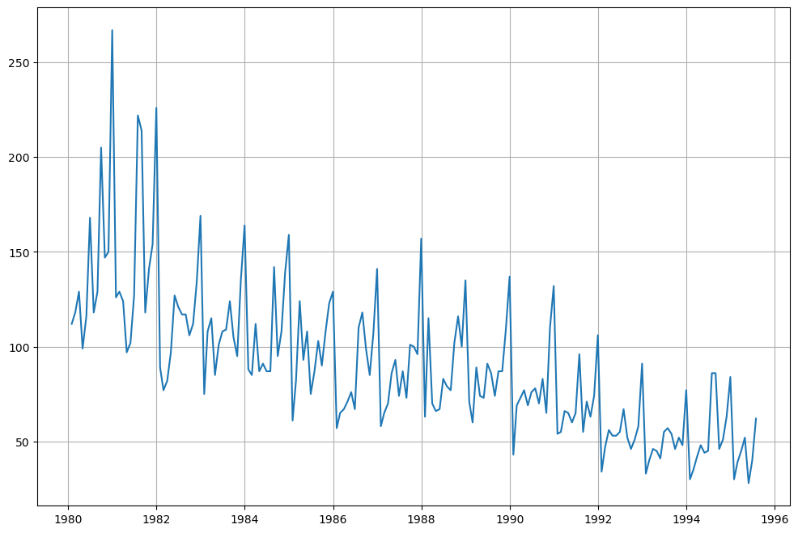

Figure 5 : Rose Wine Plot on Original Data

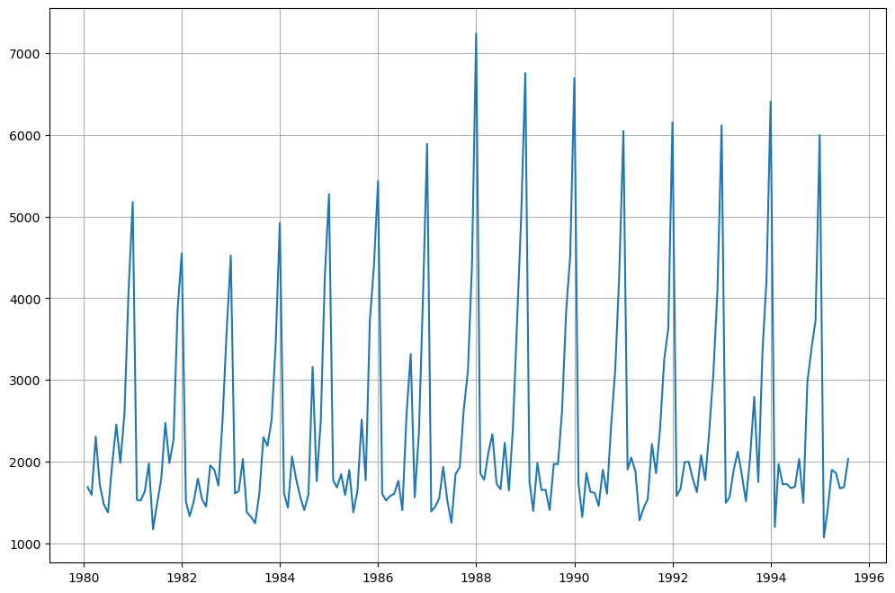

Figure 6: Sparkling Wine Plot on Original Data

### **Exploratory Data Analysis:**

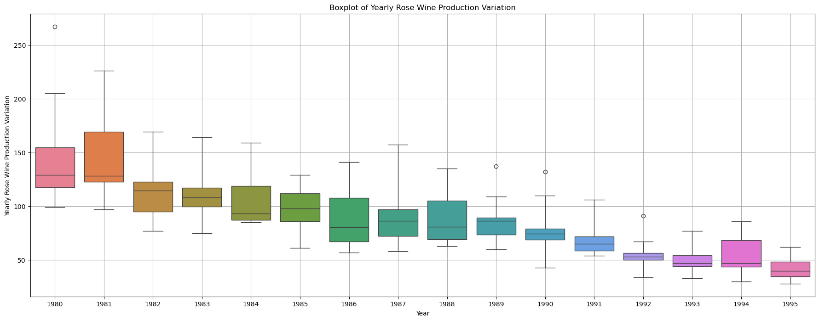

Figure 7: Yearly Production of Rose Wine

* Rose wine has mostly a downward sales trend.
* The highest sales for Rose wine can be observed in 1981 and the lowest sales in 1994.

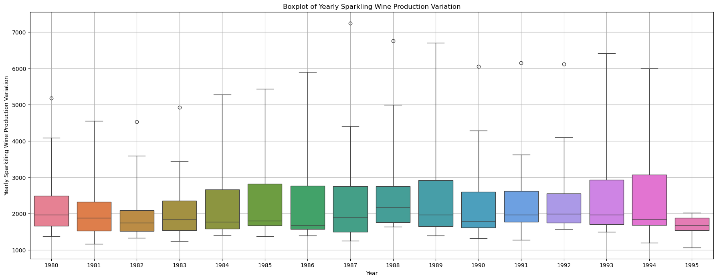

Figure 8: Yearly Production of Sparkling Wine

* Sparkling Wine sales have a variation each year.
* The years 1985 and 1986 seem to be the years with the least variation, so the 2 years show certain consistency in terms of sales.
* The highest sales for Sparkling Wine seem to happen in the year 1994 and the lowest in the year 1982.
* There is clear skewness that can be observed for Sparkling wine sales for all the years, except maybe in 1981.
* There are outliers in the yearly sales data, however as it is a Time Series, we can ignore the outlier data.
* The Sparkling wine sales appear to be going down from the year 1980 and have started increasing from the year 1983.
* The variation in Sparkling Wine sales seem to be increasing for the period 1983-1986, while the highest variation in Sparkling wine sales is in the year 1994.

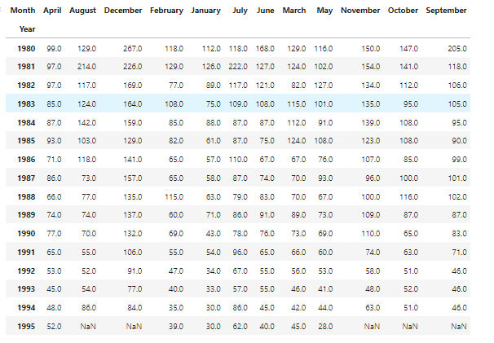

Figure 9: Monthly Sales Across years for Rose Wine

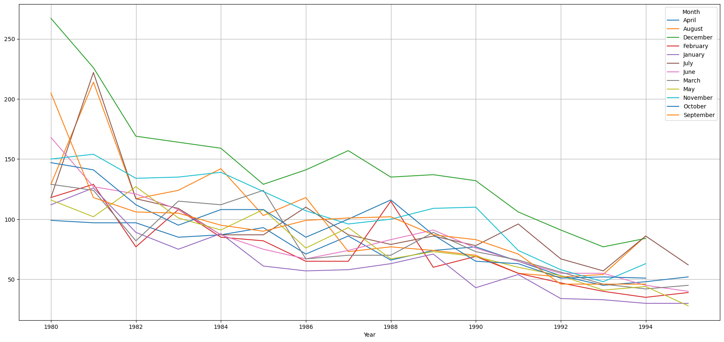

Figure 10: Monthly Production of Rose Wine

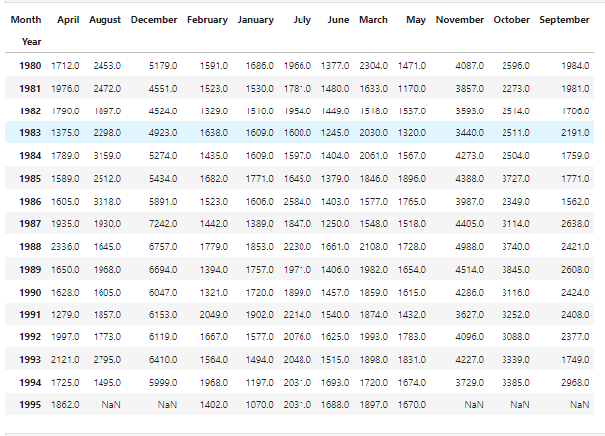

Figure 11: Monthly Sales Across years for Sparkling Wine

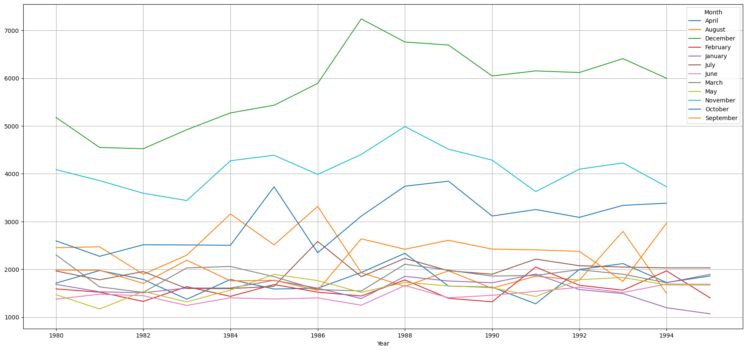

Figure 12: Monthly Production of Sparkling Wine

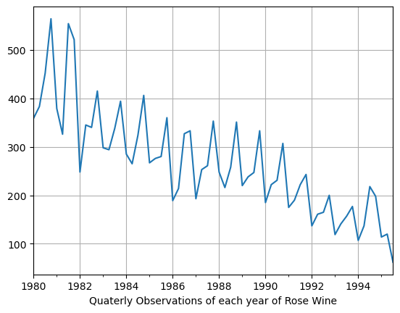

Figure 13: Quarterly Production of Rose Wine

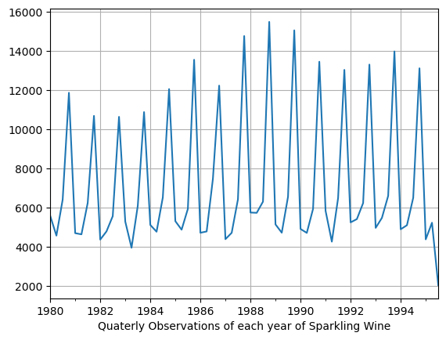

Figure 14: Quarterly Production of Sparkling Wine

* There is a seasonality element visible in both the Rose as well as Sparkling Wine time series datasets.
* The Sparkling wine seem to have a higher seasonality element as compared to Rose Wine.
* The sales have an increasing sales trend in the last quarter of the year, with Sparkling wine observing a steeper rise in sales during last quarter.
* The sales for Rose wine seem to pick up from January month and is more or less consistent till June, observes some stagnancy till September month and then starts to pick up again from October (i.e. last quarter); while for Sparkling wine, the sales is relatively low in first two quarters, slowly picks up pace during the third quarter and goes on a rise till the end of the year.
* Monthly sales data for both the type of wines shows skewness without much exceptions.

### **Decomposition:**

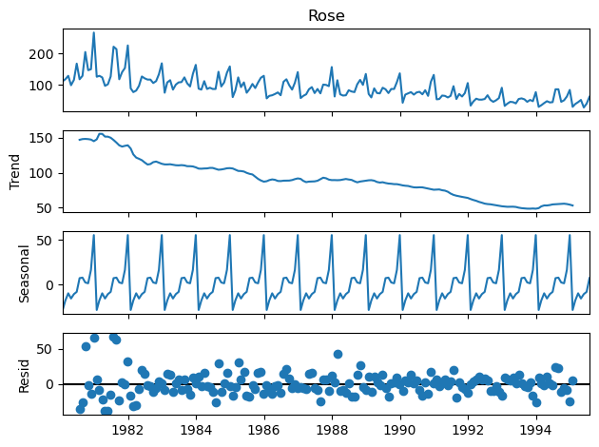

Figure 15: Additive Decomposition of Rose Wine

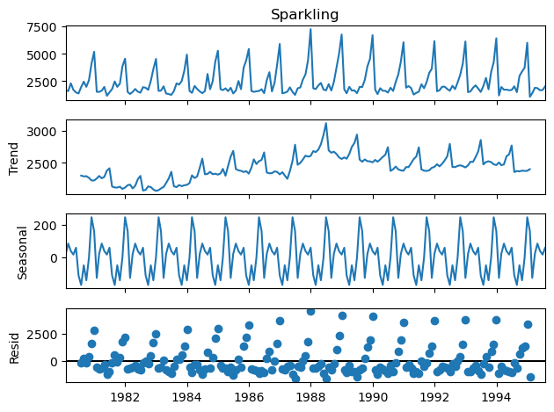

Figure 16: Additive Decomposition of Sparkling Wine

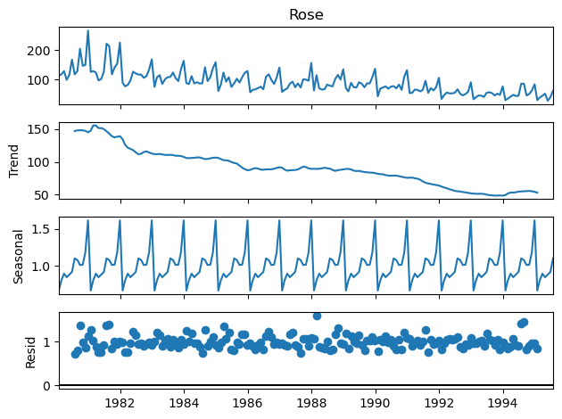

Figure 17: Multiplicative Decomposition of Rose Wine

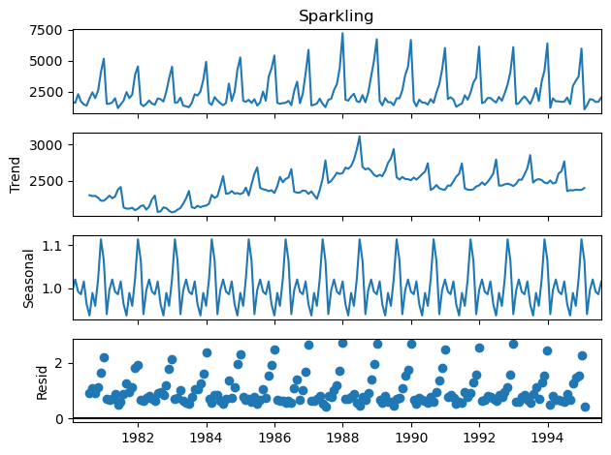

Figure 18: Multiplicative Decomposition of Sparkling Wine

* Here by just observing the Residual patterns of Additive and Multiplicative models of Rose and Sparkling datasets. It seems that
  + Rose is Multiplicative
  + Sparkling is Additive
* The plots above clearly indicate that the Wine sales are unstable and not uniform, and they have an apparent seasonality trend. Moreover, the seasonal variation seems to be more in the case of Sparkling wine as compared to the Rose wine; while the sales variation seems to be more in case of Rose wine as compared to Sparkling wine.

### **Train & Test Data Split:**

Rose & Sparkling wine data has been split into test and train datasets for further model evaluations.

* Train data for both rose & sparkling wine is till 1990
* Test data for both rose & sparkling wine is from 1991

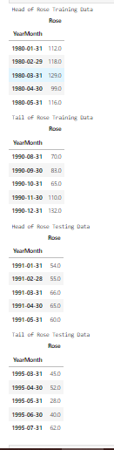 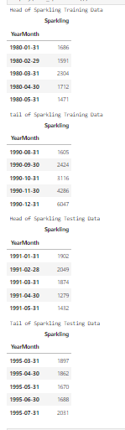

Figure 19: Train & Test Split of Rose Wine Figure 20: Train & Test Split of Sparkling Wine

* Shape of Train Rose & Sparkling wine dataset : (132, 1)
* Shape of Test Rose & Sparkling wine dataset : (55, 1)

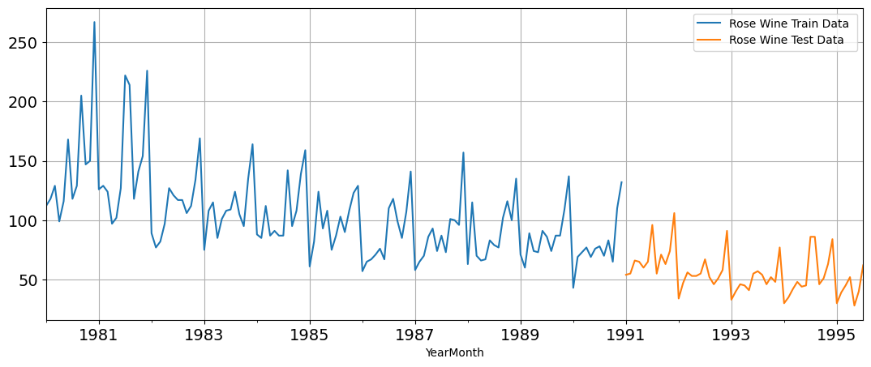

Figure 21: Train & Test Set of Rose Wine

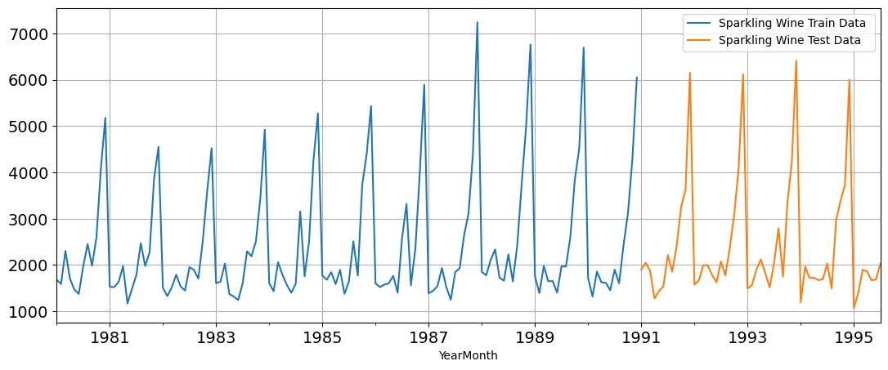

Figure 22: Train & Test Set of Sparkling Wine

### **Model Building:**

### **Linear Regression:**

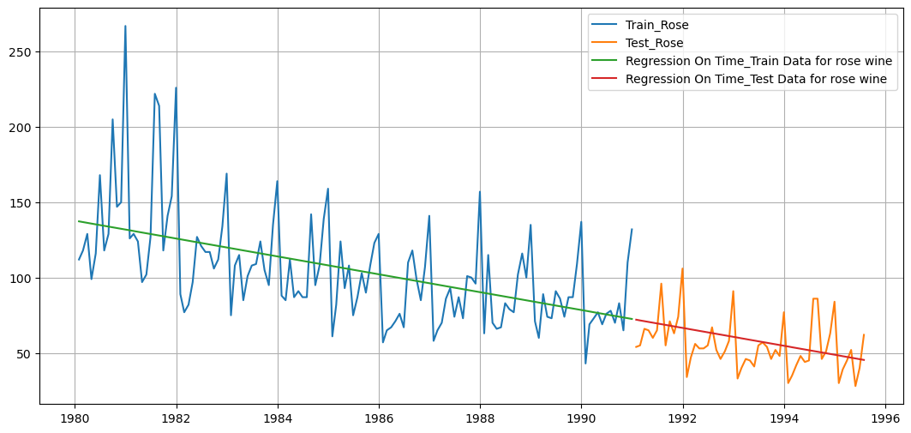

Figure 23: Linear Regression of Rose Wine

Linear Regression RSME on the Train Data of Rose Wine = 30.72

Linear Regression RSME on the Test Data of Rose Wine = 15.27

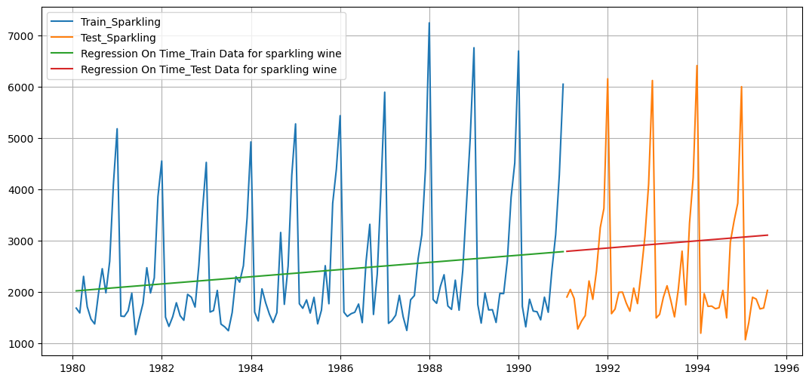

Figure 24: Linear Regression of Sparkling Wine

Linear Regression RSME on the Train Data of Sparkling Wine = 1279.32

Linear Regression RSME on the Test Data of Sparkling Wine = 1389.14

**Simple Average:**

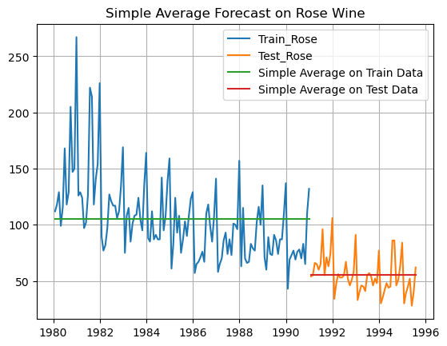

Figure 25: Simple Average of Rose Wine

RSME Simple Average forecast on the Train Data for Rose Wine = 36.034

RSME Simple Average forecast on the Test Data for Rose Wine = 15.760

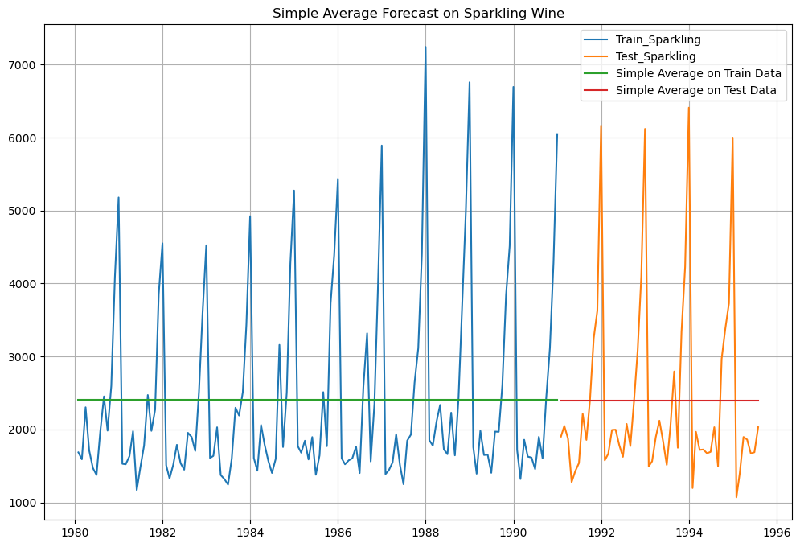

Figure 26: Simple Average of Sparkling Wine

RMSE Simple Average forecast on the Train Data for Sparkling Wine = 1298.484

RMSE Simple Average forecast on the Test Data for Sparkling Data = 1275.073

### **Moving Average:**

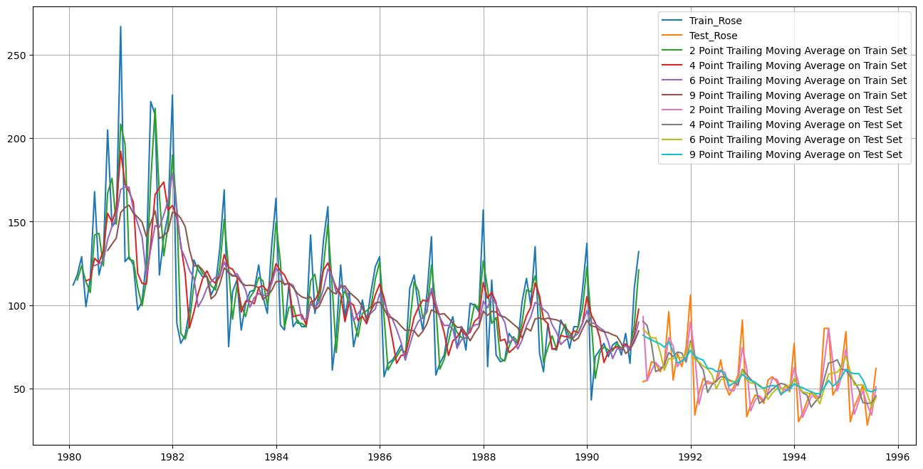

Figure 27: Moving Average of Rose Wine

2 point Moving Average Model forecast on the Test Data, RMSE is 11.529

4 point Moving Average Model forecast on the Test Data, RMSE is 14.451

6 point Moving Average Model forecast on the Test Data, RMSE is 14.567

9 point Moving Average Model forecast on the Test Data, RMSE is 14.728

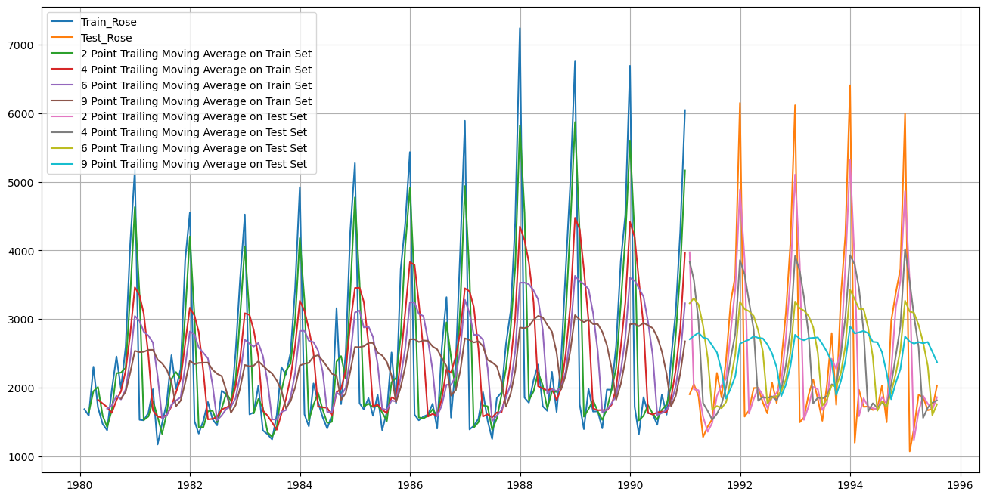

Figure 28: Moving Average of Sparkling Wine

For 2 point Moving Average Model forecast on the Test Data, RMSE is 813.401

For 4 point Moving Average Model forecast on the Test Data, RMSE is 1156.590

For 6 point Moving Average Model forecast on the Test Data, RMSE is 1283.928

For 9 point Moving Average Model forecast on the Test Data, RMSE is 1346.279

* We have built 4 models till now for both Rose and Sparkling Wine datasets
* We fitted various models to the Train split and tested it on Test split. Accuracy metrics used is Root Mean Squared Error (RMSE) on Test data
* **Model 1 - Linear Regression**
  + We regressed variables ‘Rose’ and ‘Sparkling’ against their individual time instances
  + We modified the datasets and tagged individual sales to their time instances
  + TEST RMSE ROSE = 15.27 | TEST RMSE SPARKLING = 1389.14
* **Model 2 - Simple Average**
  + All future predictions are the same as the simple average of all data till today
  + TEST RMSE ROSE = 15.76 | TEST RMSE SPARKLING = 1275.073
* **Model 3 - Moving Average (MA)**
  + We calculate rolling means (Moving averages) over different intervals for the whole train data
  + 2 Point Moving Average:

TEST RMSE ROSE = 11.53 | TEST RMSE SPARKLING = 813.401

* + 4 Point Moving Average:

TEST RMSE ROSE = 14.45 | TEST RMSE SPARKLING = 1156.590

* + 6 Point Moving Average:

TEST RMSE ROSE = 14.57 | TEST RMSE SPARKLING = 1283.928

* + 9 Point Moving Average:

TEST RMSE ROSE = 14.73 | TEST RMSE SPARKLING = 1346.279

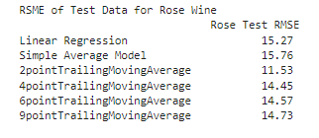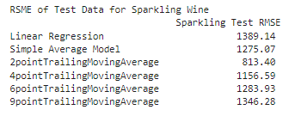

Figure 29: Test RSME of all 3 models of Rose & Sparkling Wine

* Till now, Best Model which gives lowest RMSE score for both Rose and Sparkling is 2 Point Moving Average Model
* We’ll continue to forecast using Exponential Smoothing Models for both datasets of Rose and Sparkling Wine Sales
* We’ll build following Exponential Smoothing Models –
  + Simple Exponential Smoothing
  + Double Exponential Smoothing (Holt’s Model)
  + Triple Exponential Smoothing (Holt-Winter Model)

### **Single Exponential Smoothing:**

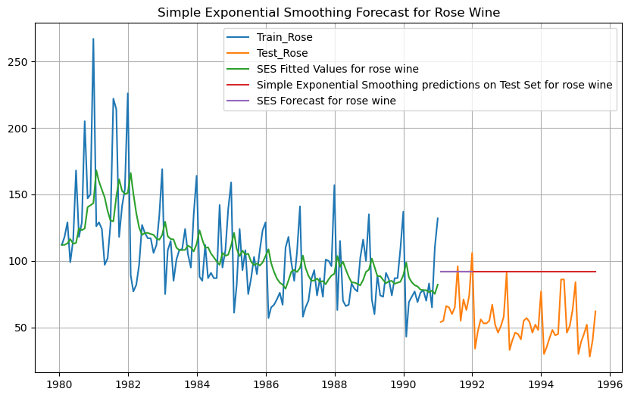

Figure 30: Simple Exponential Smoothing of Rose Wine

Simple Exponential Smoothing Model forecast on the Test Data, RMSE is 41.362

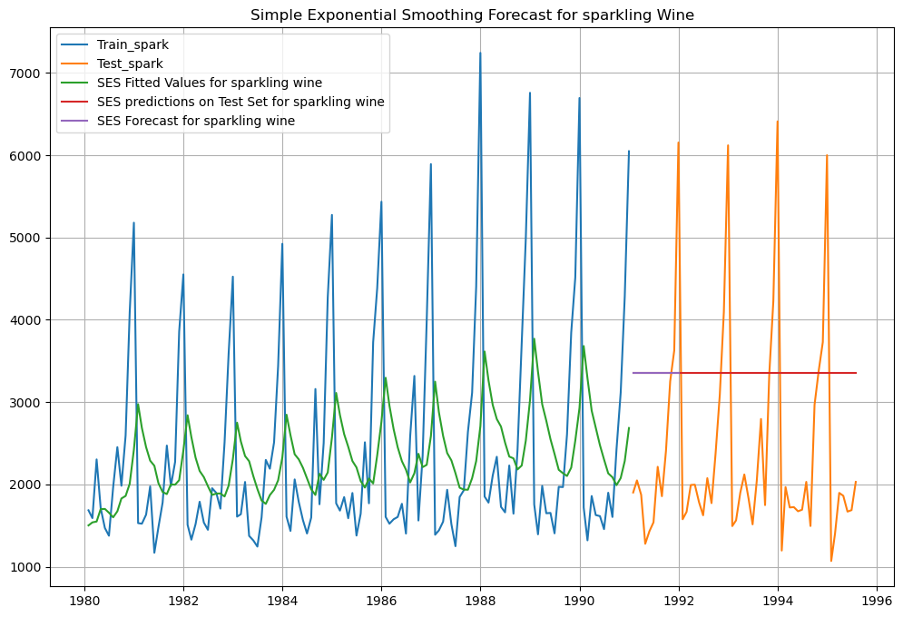

Figure 31: Simple Exponential Smoothing of Sparkling Wine

Simple Exponential Smoothing Model forecast on the Test Data, RMSE is 1595.207

Best Model till now for Rose and Sparkling is 2 Point Moving Average Model

### **Double Exponential Smoothing (Holt’s Model):**

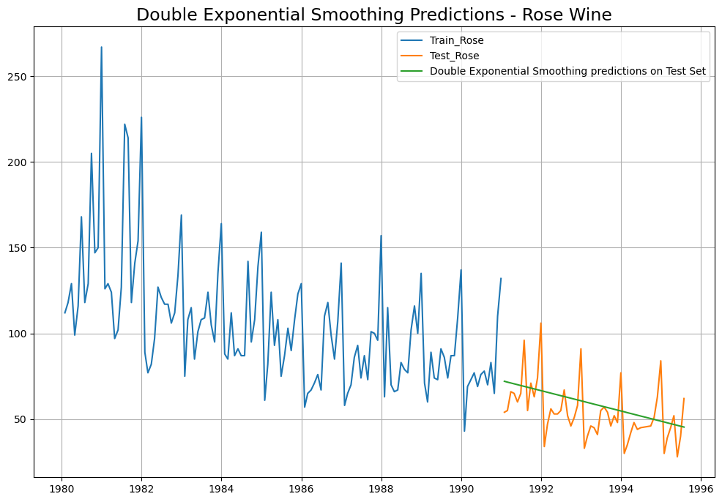

Figure 32: Double Exponential Smoothing of Rose Wine

Double Exponential Smoothing Model forecast on the Test Data, RMSE is 15.268

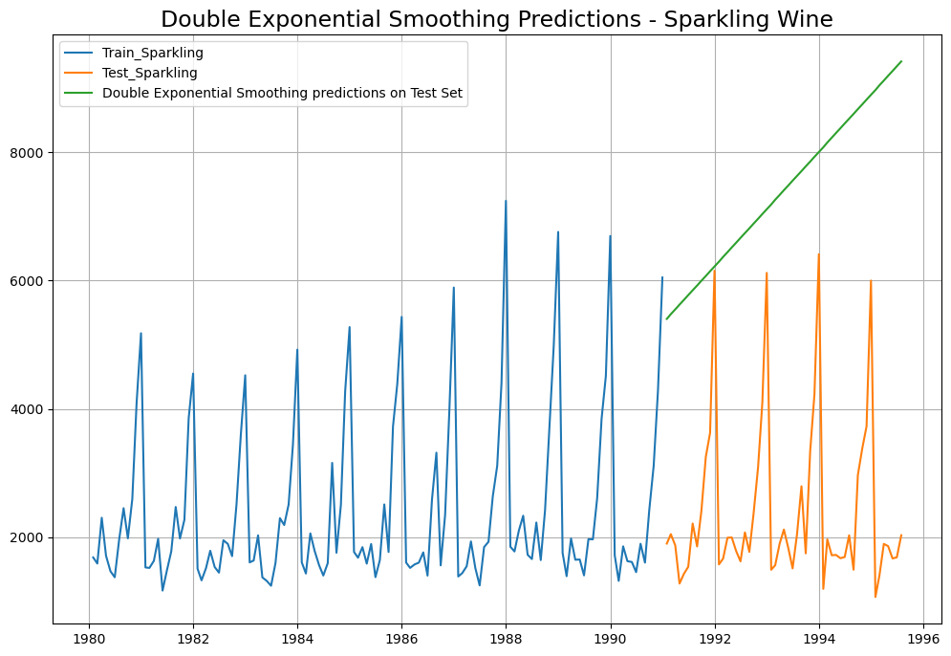

Figure 33: Double Exponential Smoothing of Sparkling Wine

Double Exponential Smoothing Model forecast on the Test Data, RMSE is 5291.87

* In Rose - DES has picked up the trend well. DES seems to perform better than SES here
* In Sparkling - DES shows a non-existent trend. DES does not perform well here
* Best Model till now for Rose and Sparkling is 2 Point Moving Average Model

### **Triple Exponential Smoothing (Holt - Winter Model) – Additive Model:**

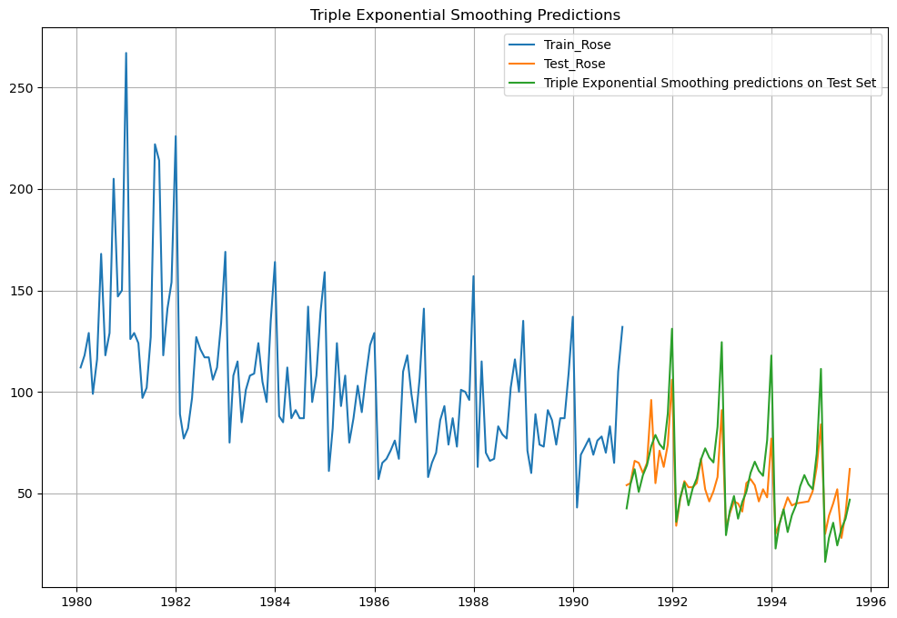

Figure 34: Triple Exponential Smoothing of Rose Wine - Additive

Triple Exponential Smoothing Model forecast on the Test Data, RMSE is 14.26

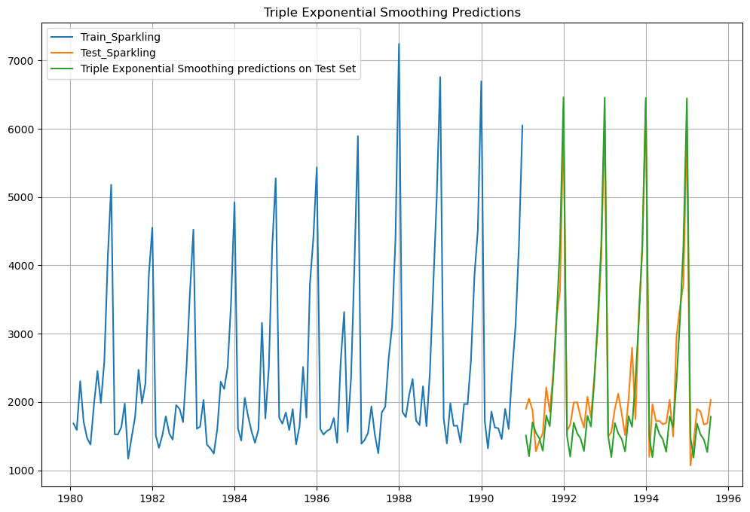

Figure 35: Triple Exponential Smoothing of Sparkling Wine - Additive

Triple Exponential Smoothing Model forecast on the Test Data, RMSE is 380.09

**Triple Exponential Smoothing (Holt - Winter Model) – Multiplicative Model:**

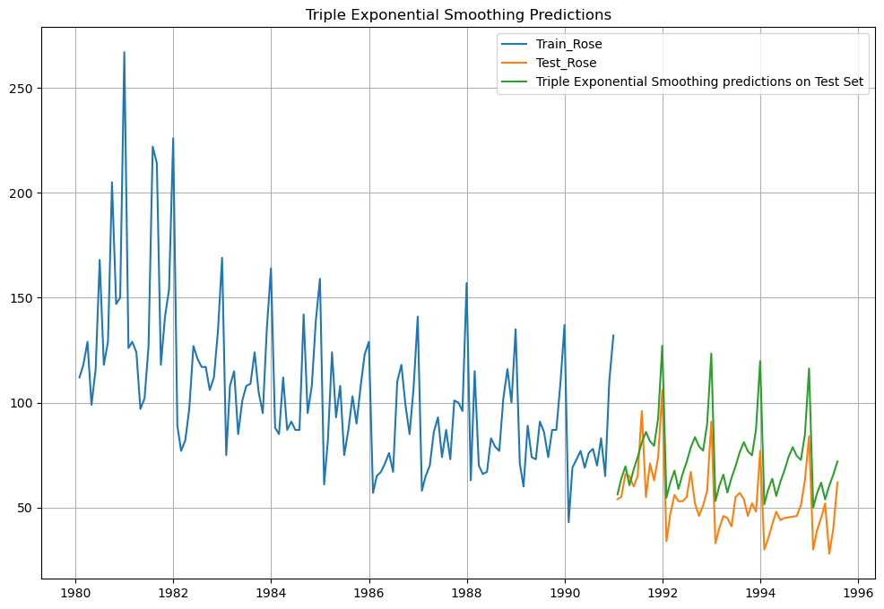

Figure 36: Triple Exponential Smoothing of Rose Wine – Multiplicative

RSME of Triple Exponential Smoothing Model forecast on the Test Data : 22.101

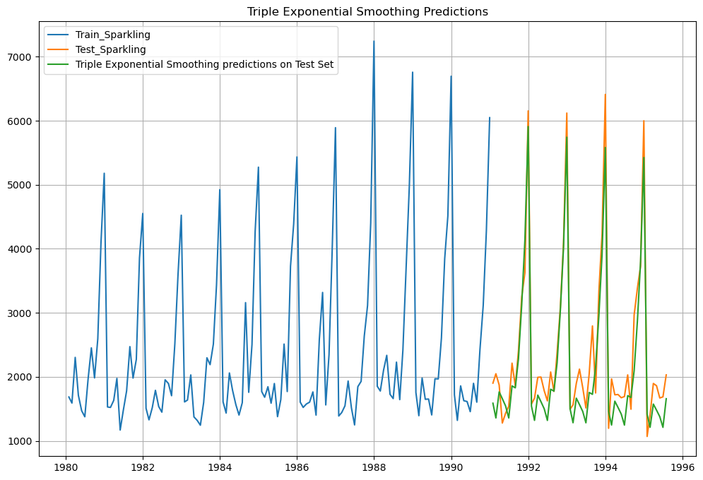

Figure 37: Triple Exponential Smoothing of Sparkling Wine – Multiplicative

RSME of Triple Exponential Smoothing Model forecast on the Test Data : 386.836

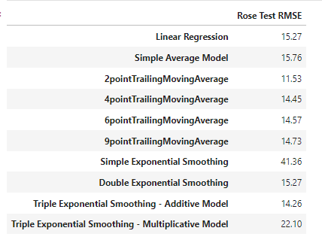

Figure 38: Test RSME of all models of Rose Wine

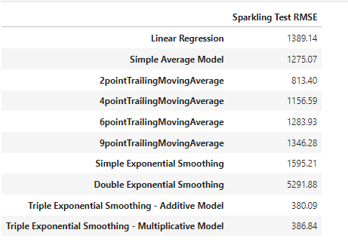

Figure 39: Test RSME of all models of Sparkling Wine

Best Model till now,

* Rose Wine : 2 Point Moving Average Model
* Sparkling Wine : Triple Exponential Smoothing – Additive Model

### **Stationary Test:**

Dickey-Fuller Test - Dicky Fuller Test on the timeseries is run to check for stationarity of data.

* Null Hypothesis H0: Time Series is non-stationary.

Alternate Hypothesis 𝑯𝒂: Time Series is stationary.

* So, in ADF Test, if p-value < 0.05 - We reject the Null Hypothesis and hence conclude that given Time Series is Stationary
* So, in ADF Test, if p-value > 0.05 - We fail to reject the Null Hypothesis and hence conclude that given Time Series is Not Stationary
* If Time Series is not Stationary then we apply one level of differencing and check for Stationarity again.
* Again, if the Time Series is still not Stationary, we apply one more level of differencing and check for Stationarity again
* Once the Time Series is Stationary then we are ready to apply ARIMA / SARIMA models

**Stationarity of Rose Wine Dataset:**

* Augmented Dicky-Fuller Test was applied to the whole Rose dataset
  + We found, p-value = 0.343
  + Here, p-value > 0.05
  + We fail to reject the Null Hypothesis and hence conclude that Rose Wine Time Series is Not Stationary
  + We take 1 level of differencing and check again for Stationarity
  + Now, p-value = 1.656242e-12
  + Now, p-value < 0.05
  + Now, we reject the Null Hypothesis and conclude that Rose Time Series is Stationary with a lag of 1

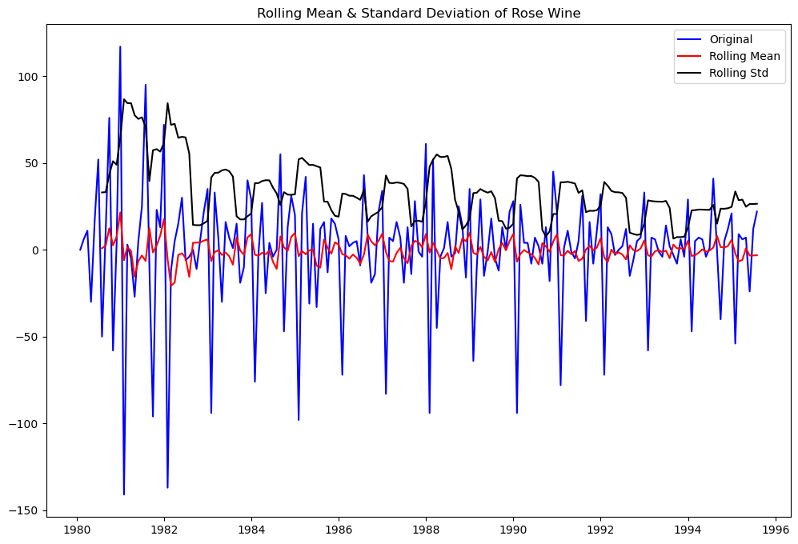

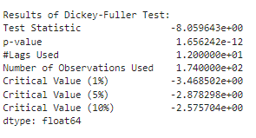

Figure 40: Stationary of Rose Wine

**Stationarity of Sparkling Wine Dataset:**

* Augmented Dicky-Fuller Test was applied to the whole Sparkling dataset
  + We found, p-value = 0.60106
  + Here, p-value > 0.05
  + We fail to reject the Null Hypothesis and hence conclude that Sparkling Wine Time Series is Not Stationary
  + We take 1 level of differencing and check again for Stationarity
  + Now, p-value = 0.000000
  + Now, p-value < 0.05
  + Now, we reject the Null Hypothesis and conclude that Sparkling Time Series is Stationary with a lag of 1

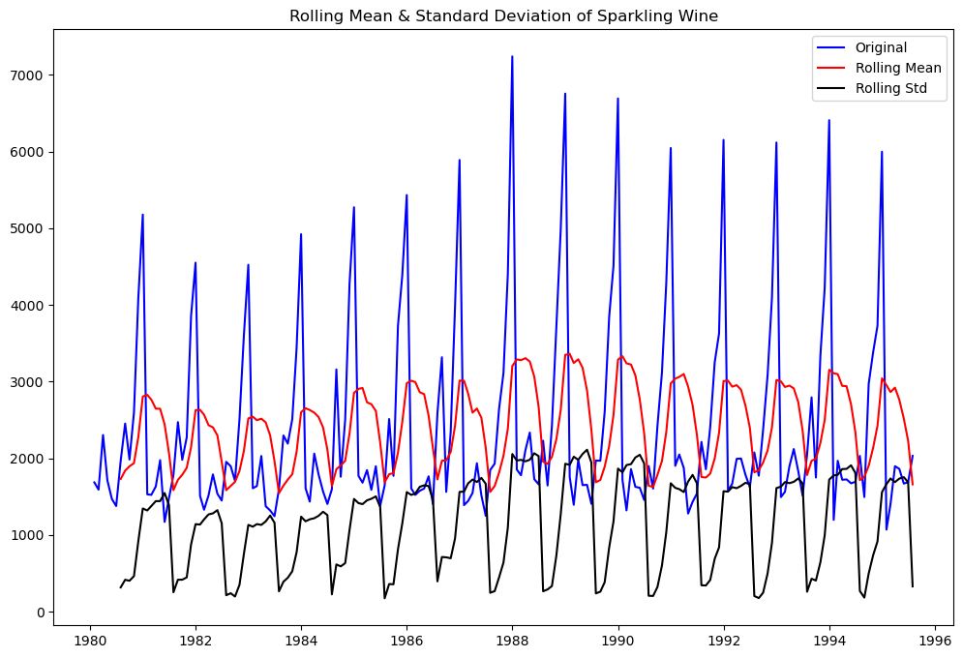

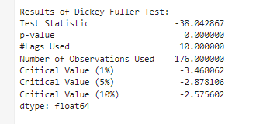

Figure 41: Stationary of Sparkling Wine

### **ACF & PACF:**

### **Auto-Correlation Function (ACF) –**

### Autocorrelation refers to how correlated a time series is with its past values.

### ‘Auto’ part of Autocorrelation refers to Correlation of any time instance with its previous time instance in the SAME Time Series

### ACF is the plot used to see the correlation between the points, up to and including the lag unit.

### ACF indicates the value of ‘q’ - which is the Moving Average parameter in ARIMA / SARIMA models

**Partial Auto-Correlation Function (PACF) –**

* Partial Autocorrelation refers to how correlated a time series is with its past lag values.
* PACF is the plot used to see the correlation between the lag points
* PACF indicates the value of ‘p’ - which is the Auto-Regressive parameter in ARIMA / SARIMA models

### **Rose Wine:**

* Observing the cut-offs in ACF and PACF plots for Rose dataset, we get –

FOR ARIMA: p = 2, q = 2 and difference d = 1

FOR SARIMA: p = 2, q = 2, d = 1 and P = 2, D = 1, Q = 2, Seasonality=12

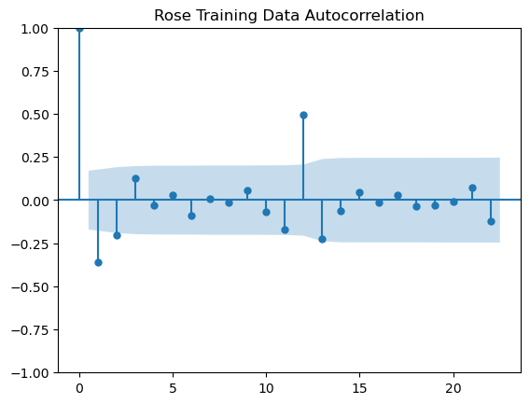

Figure 42: ACF of Auto ARIMA of Rose Wine

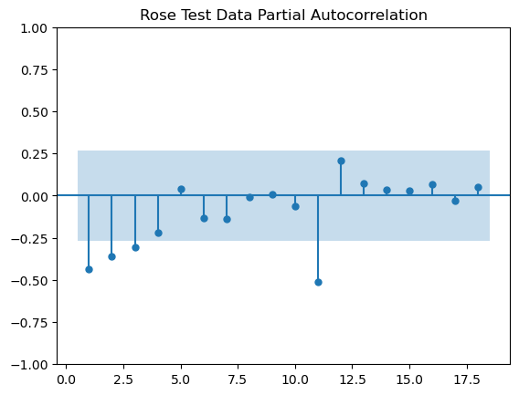

Figure 43: PACF of Auto ARIMA of Rose Wine

### **ACF & PACF – Sparkling Wine:**

* Observing the cut-offs in ACF and PACF plots for Sparkling dataset, we get –

FOR ARIMA: p = 0, q = 0 and difference d = 1

FOR SARIMA: p = 0, q = 0, d = 1 and P = 0, 1, 2, 3 | D = 0, Q = 1, 2, 3

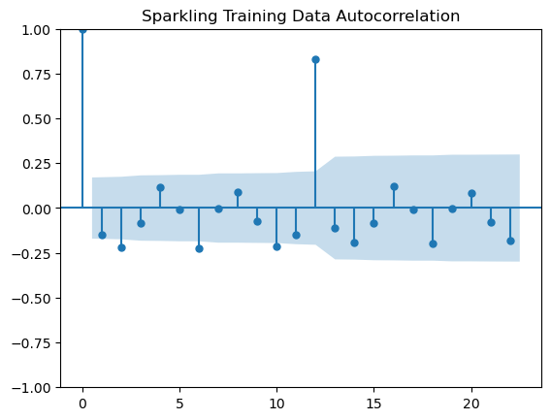

Figure 44: ACF of Auto ARIMA of Sparkling Wine

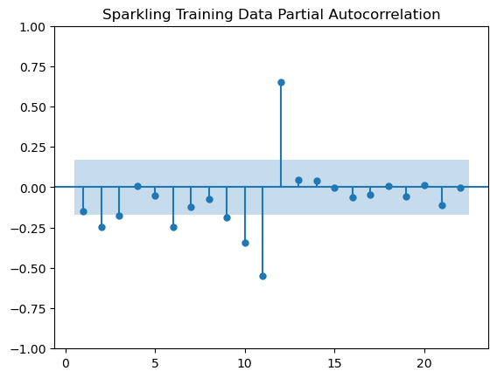

Figure 45: PACF of Auto ARIMA of Sparkling Wine

### **Auto ARIMA:**

* We create a grid of all possible combinations of (p, d, q)
* Range of p = Range of q = 0 to 3, Constant d = 1

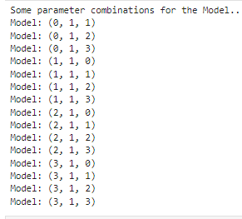

Figure 46: Model Combinations of Rose & Sparkling Wine

* We fit ARIMA models to each of these combinations for both datasets
* We choose the combination with the least Akaike Information Criteria (AIC)
* We fit ARIMA to this combination of (p, d, q) to the Train set and forecast on the Test set
* Finally, we check the accuracy of this model by checking RMSE of Test set

For Rose, Best Combination with Least AIC is - (p, d, q) is (2, 1, 3)

RMSE of Rose Wine - Auto ARIMA : 36.807

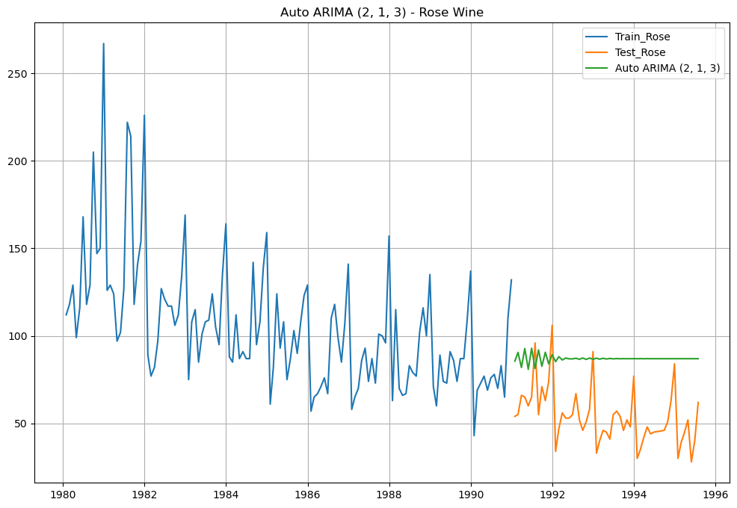

Figure 47: Auto ARIMA of Rose Wine

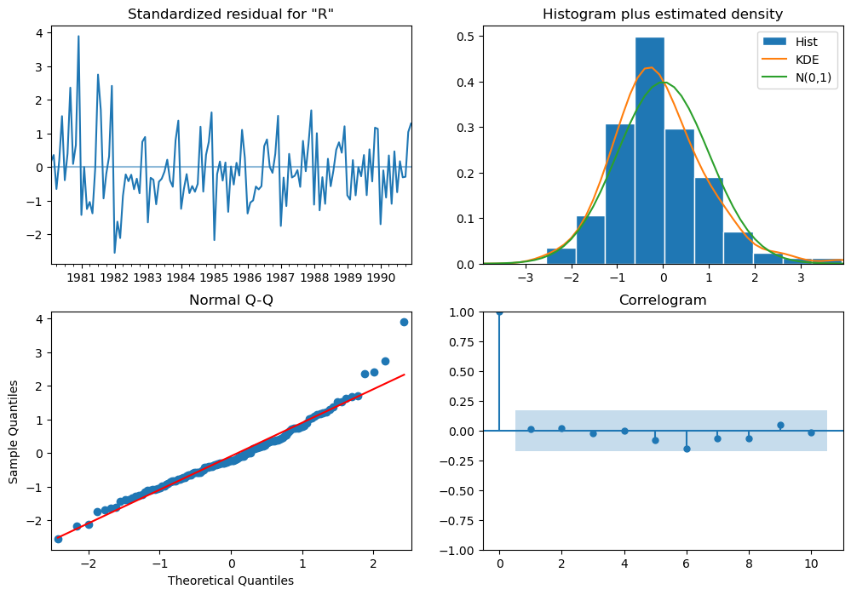

Figure 48: Diagnostic Plot of Auto ARIMA of Rose Wine

For Sparkling, Best Combination with Least AIC is - (p, d, q) is (2, 1, 2)

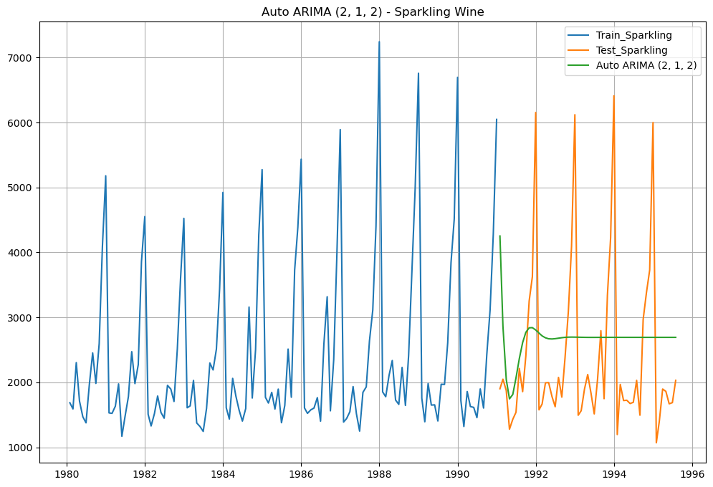

Figure 49: Auto ARIMA of Sparkling Wine

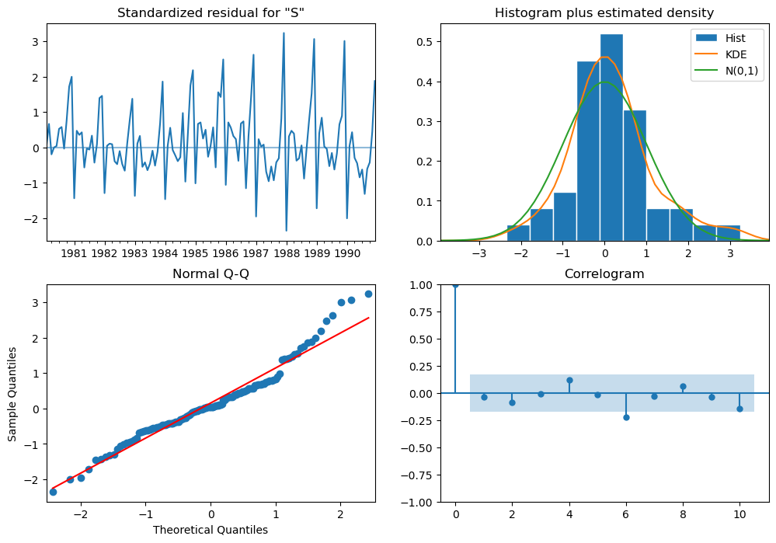

Figure 50: Diagnostic Plot of Auto ARIMA of Sparkling Wine

**Manual ARIMA:**

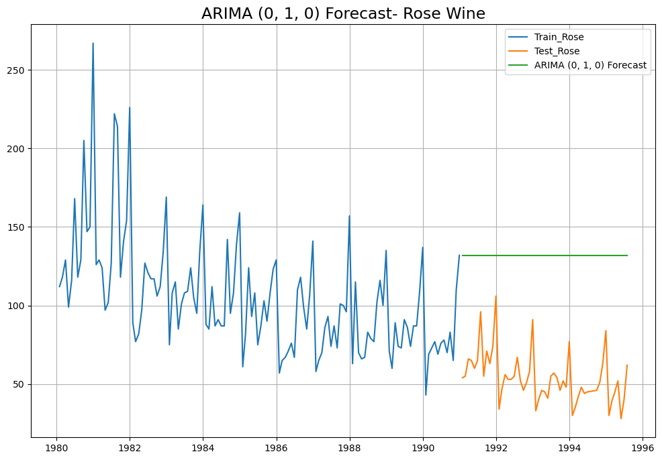

Figure 51: Manual ARIMA of Rose Wine

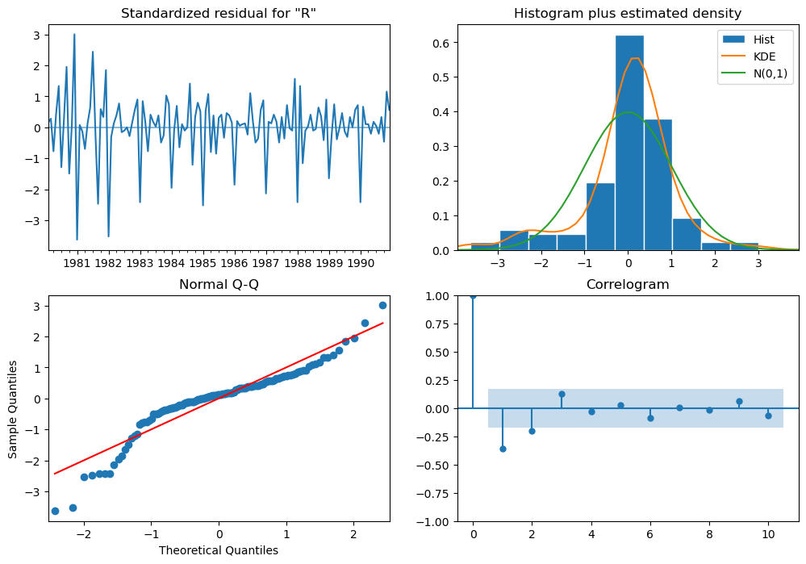

Figure 52: Diagnostic Plot of Manual ARIMA of Rose Wine

RMSE of Rose Wine - Manual ARIMA : 79.718

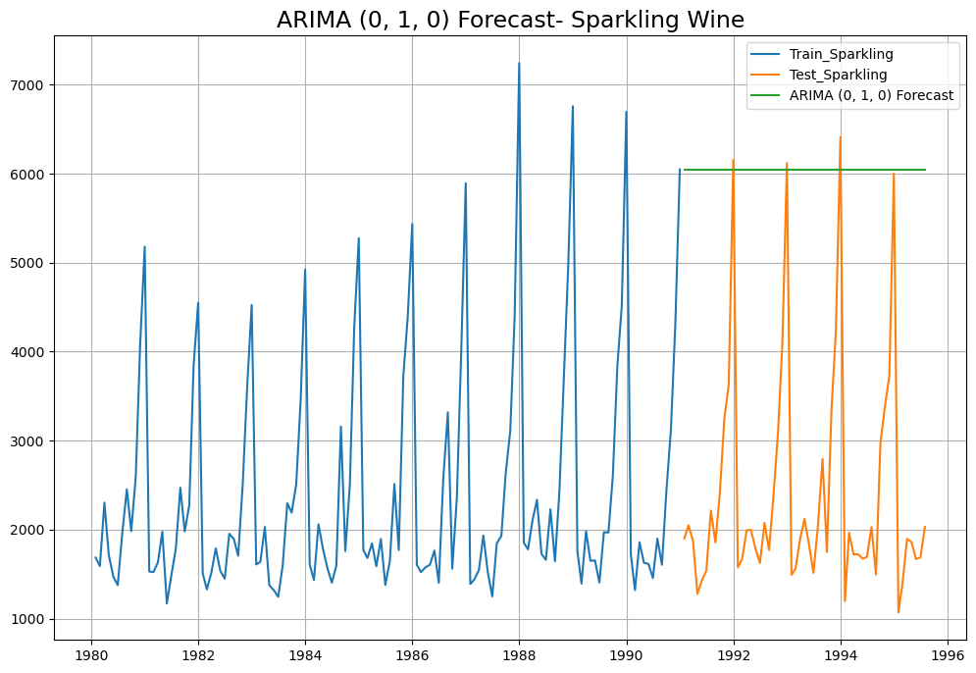

Figure 53: Manual ARIMA of Sparkling Wine

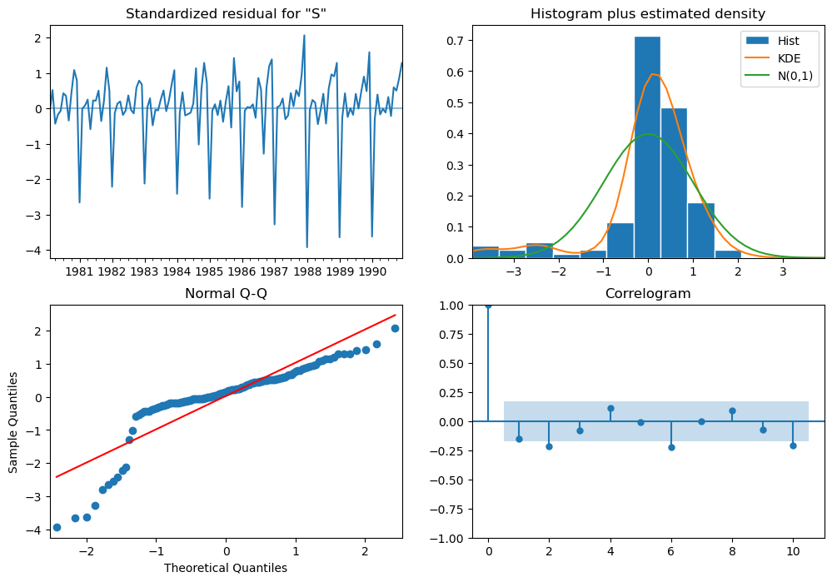

Figure 54: Diagnostic Plot of Manual ARIMA of Sparkling Wine

RMSE of Sparkling Wine - Manual ARIMA: 3864.279

**Auto SARIMA:**

* We create a grid of all possible combinations of (p, d, q) along with Seasonal (P, D, Q) & Seasonality of 12 (for both datasets)
* Range of p = Range of q = 0 to 3, Constant d = 1
* Range of Seasonal P = Range of Seasonal Q = 0 to 3, Constant D = 1, Seasonality m = 12

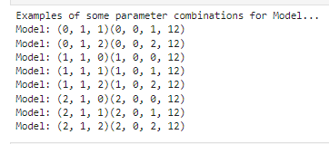

Figure 55: Model Combinations of Rose & Sparkling Wine

* We fit SARIMA models to each of these combinations and select with least AIC
* We fit SARIMA to this best combination of (p, d, q) (P, D, Q, m) to the Train set and forecast on the Test set. Then, we check accuracy using RMSE on Test set

**Auto SARIMA - Rose Wine – (1,1,1) (2,0,3,6):**

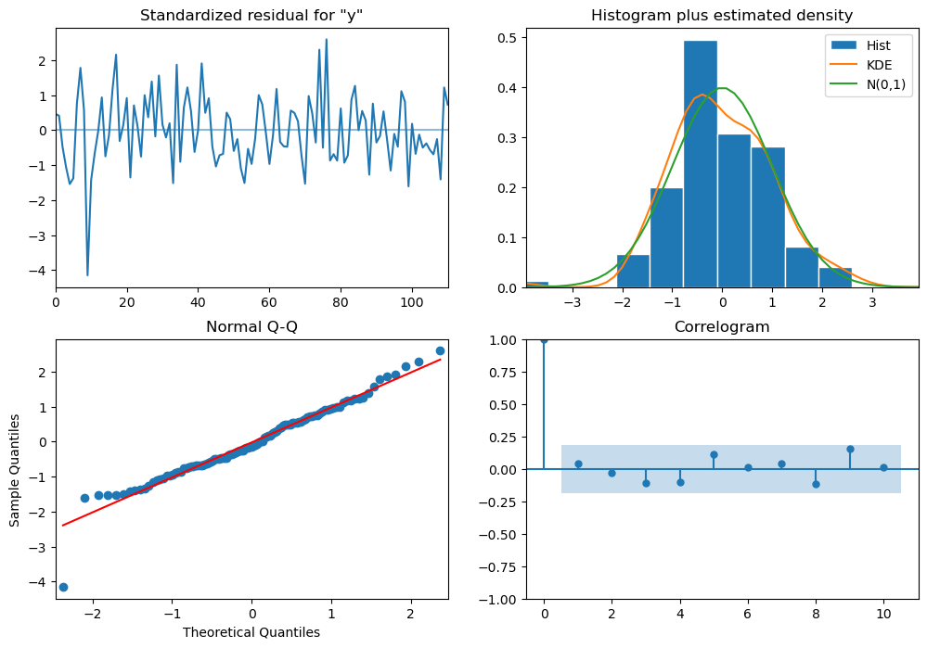

Figure 56: Diagnostic Plot of Auto SARIMA of Rose Wine – (1,1,1) (2,0,3,6)

RMSE of Test set for rose wine : 29.76

**Auto SARIMA - Rose Wine – (1,1,2) (2,0,2,12):**

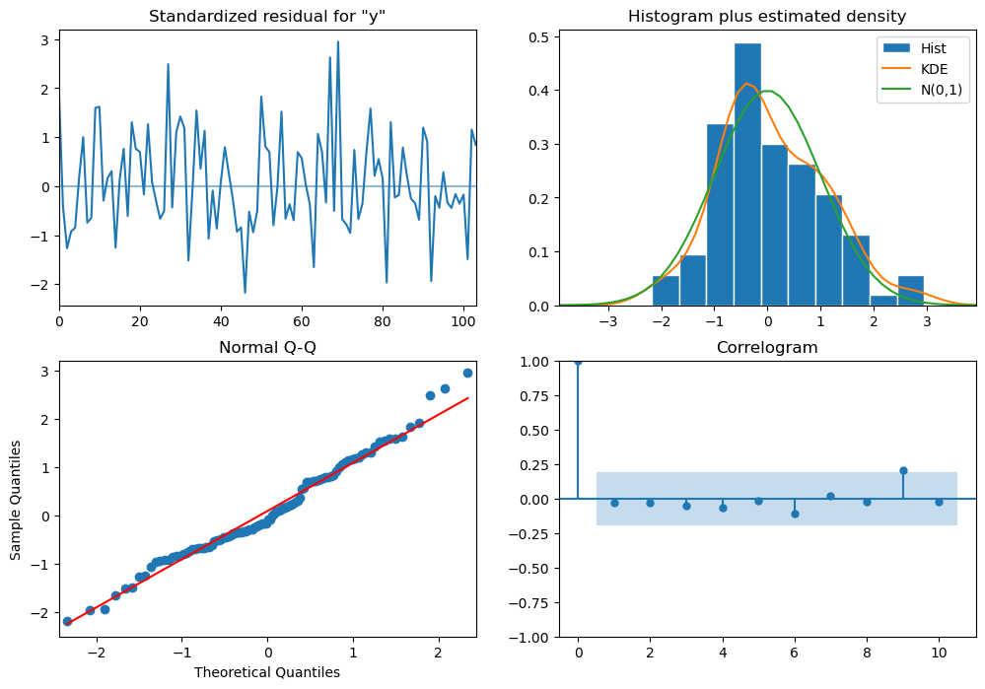

Figure 57: Diagnostic Plot of Auto SARIMA of Rose Wine – (1,1,2)) (2,0,2,12)

RMSE of Test set for rose wine : 26.928

**Auto SARIMA - Sparkling Wine – (0,1,1) (2,0,2,6):**

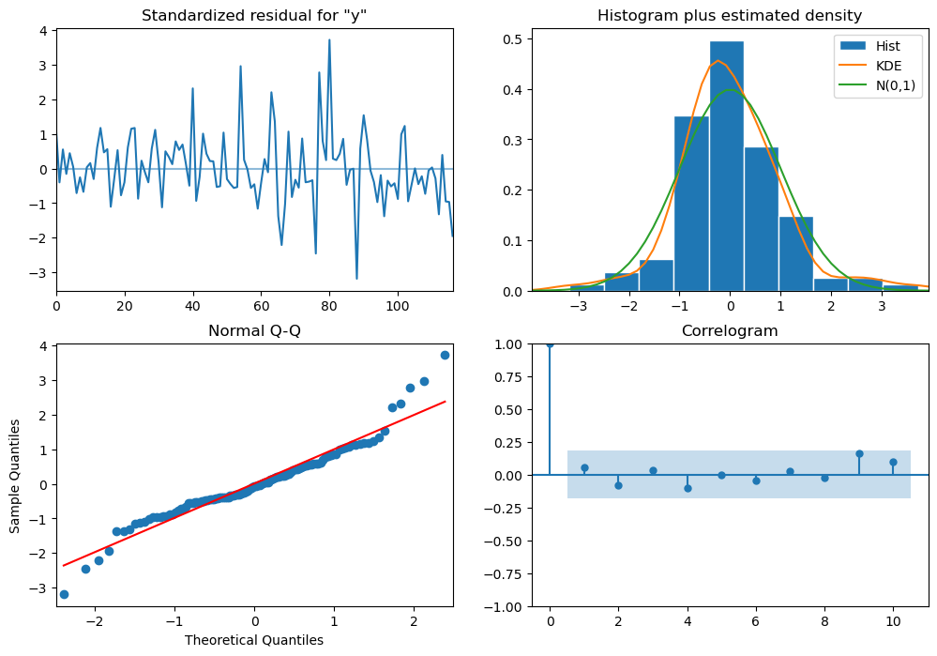

Figure 58: Diagnostic Plot of Auto SARIMA of Sparkling Wine – (0,1,1)) (2,0,2,6)

RMSE of Test set for Sparkling wine : 631.373

**Auto SARIMA - Sparkling Wine – (1,1,2) (2,0,2,12):**

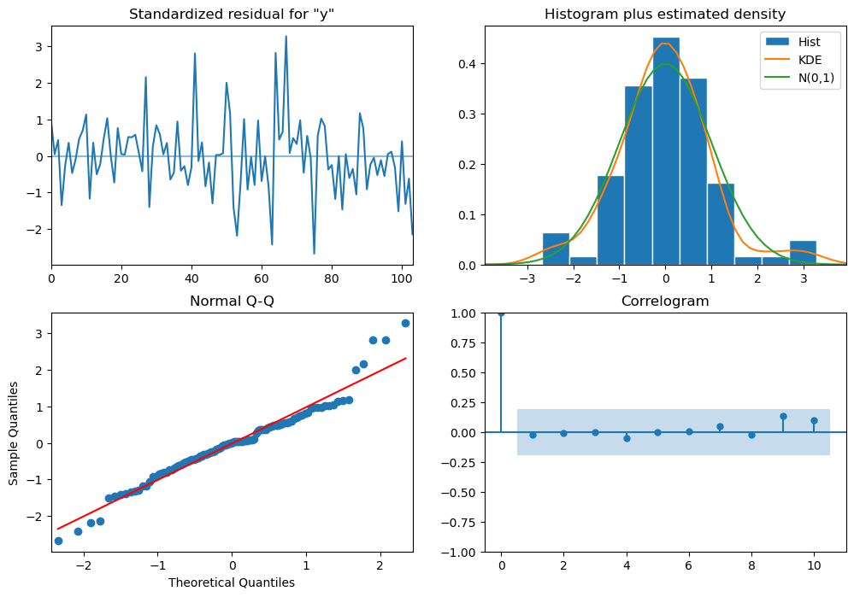

Figure 59: Diagnostic Plot of Auto SARIMA of Sparkling Wine – (1,1,2)) (2,0,2,12)

RMSE of Test set for Sparkling wine: 548.080

### **Manual SARIMA - :**

### **Rose Wine – (0,1,0) (1,1,3,6) :**

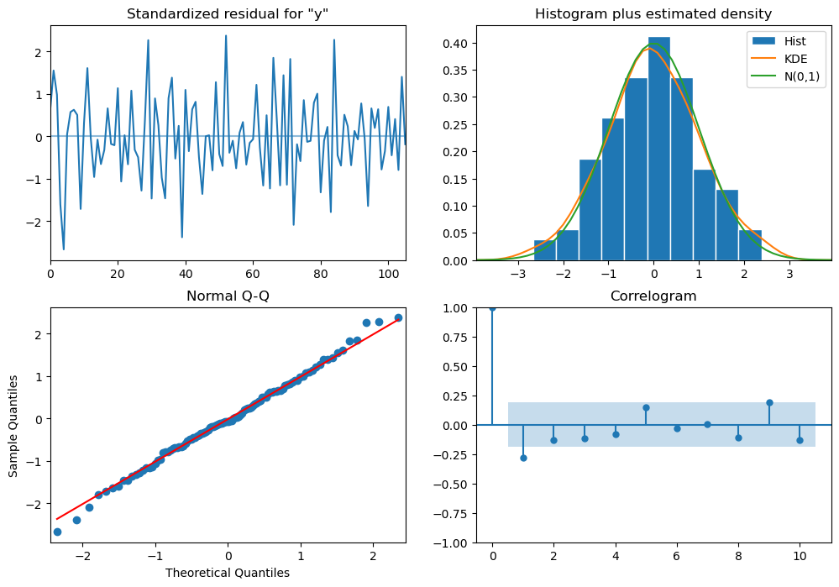

Figure 60: Diagnostic Plot of Manual SARIMA of Rose Wine – (0,1,0) (1,1,3,6)

RMSE of Rose Wine – Manual SARIMA: 37.874

**Rose Wine – (2,1,2) (2,1,2,12) :**

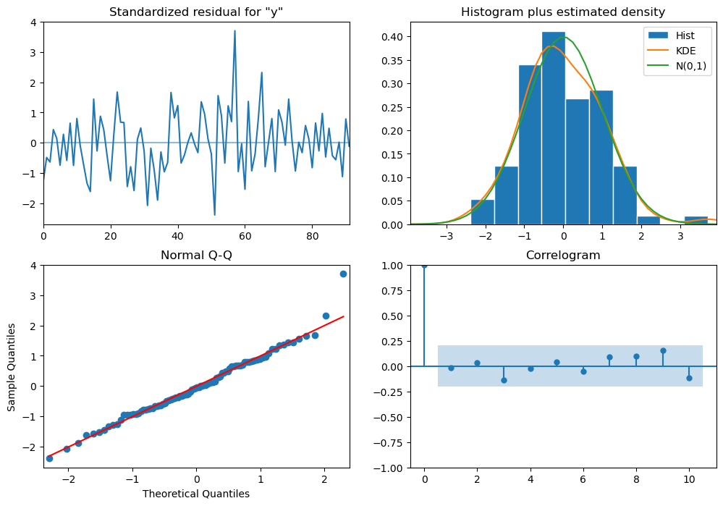

Figure 61: Diagnostic Plot of Manual SARIMA of Rose Wine – (2,1,2) (2,1,2,12)

RMSE of Rose Wine – Manual SARIMA: 37.874

**Sparkling Wine – (0,1,0) (1,1,3,6) :**

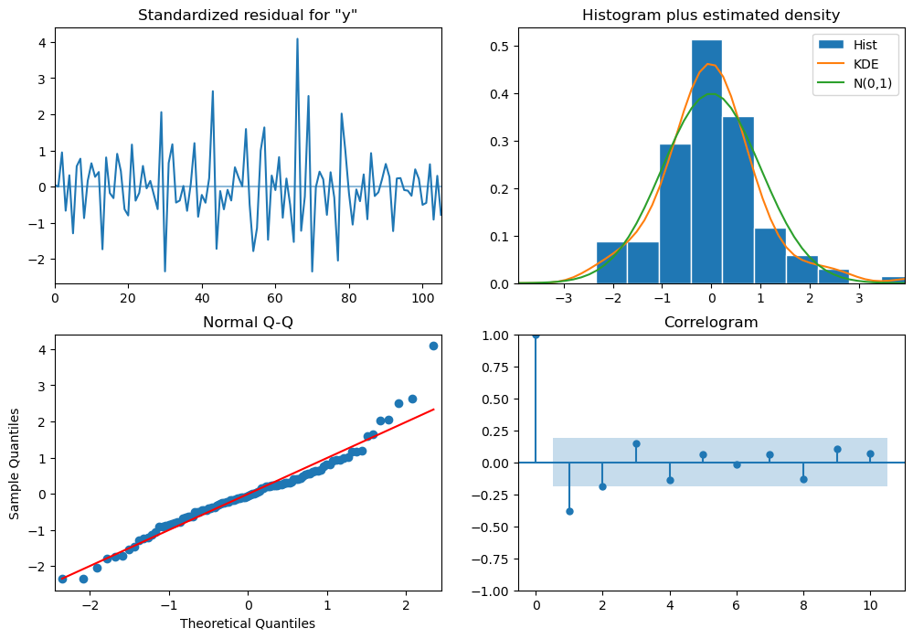

Figure 62: Diagnostic Plot of Manual SARIMA of Sparkling Wine – (0,1,0) (1,1,3,6)

RMSE of Sparkling Wine – Manual SARIMA: 1914.641

**Sparkling Wine – (2,1,2) (2,1,2,12) :**

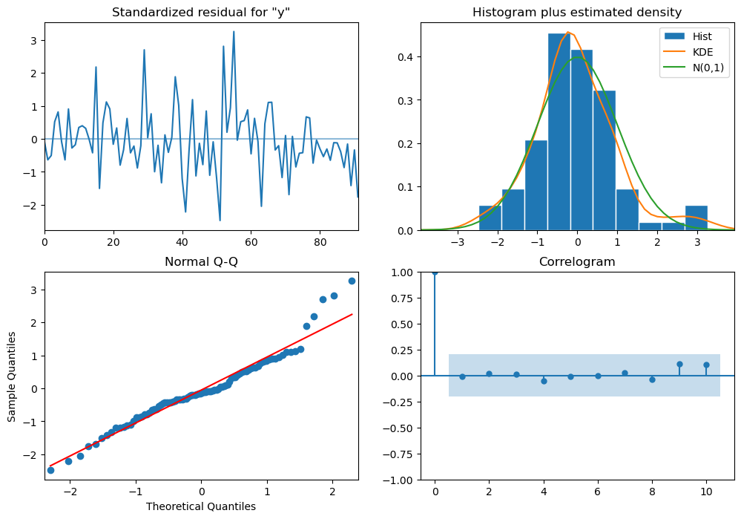

Figure 63: Diagnostic Plot of Manual SARIMA of Sparkling Wine – (2,1,2) (2,1,2,12)

RMSE of Sparkling Wine – Manual SARIMA: 1914.641

**Model Evaluation for next 12 Months:**

**Rose Wine:**

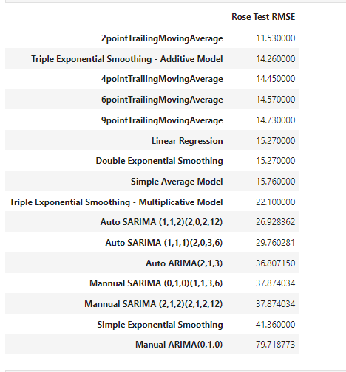

Figure 64: RSME Values of Rose Wine in Ascending Order

The Best Model so far is 2 point Trailing Moving Average.

**2 Point Trailing Moving Average:**

|  |  |
| --- | --- |
| YearMonth | Forecast |
| 31-08-1995 | 48.80556 |
| 30-09-1995 | 48.80556 |
| 31-10-1995 | 48.80556 |
| 30-11-1995 | 48.80556 |
| 31-12-1995 | 48.80556 |
| 31-01-1996 | 48.80556 |
| 29-02-1996 | 48.80556 |
| 31-03-1996 | 48.80556 |
| 30-04-1996 | 48.80556 |
| 31-05-1996 | 48.80556 |
| 30-06-1996 | 48.80556 |
| 31-07-1996 | 48.80556 |

Table 1: Rose Wine Forecast for next 12 months - 2 point Moving Average

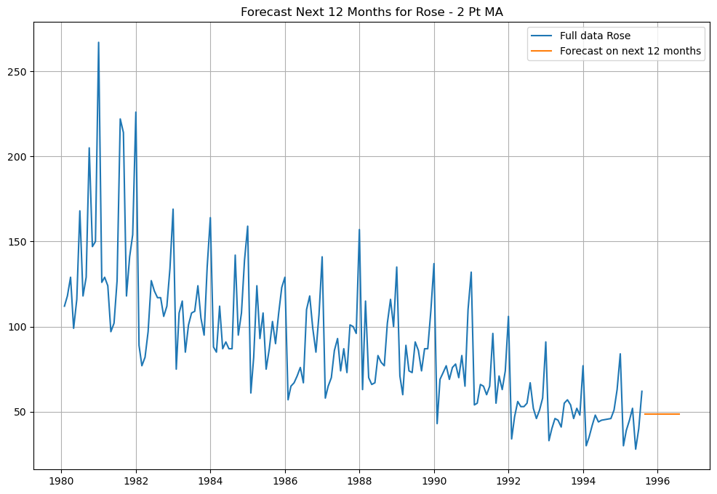

Figure 65: Rose Wine Forecast for next 12 months - 2 point Moving Average

Based on the above forecast, it can be said that the model is not predicting well. So, We forecast on the 2nd best model – Triple Exponential Smoothing – Additive Model

**Triple Exponential Smoothing – Additive Model:**

Here, we have a scenario where our training data was stationary but our full data was not stationary. So, we will use the same parameters as our training data but with adding a level of differencing which is needed for the data to be stationary.

|  |  |
| --- | --- |
| **YearMonth** | **Forecast** |
| 31-08-1995 | 49.83258 |
| 30-09-1995 | 46.62195 |
| 31-10-1995 | 45.41716 |
| 30-11-1995 | 60.07118 |
| 31-12-1995 | 98.23646 |
| 31-01-1996 | 13.89411 |
| 29-02-1996 | 24.13636 |
| 31-03-1996 | 31.66632 |
| 30-04-1996 | 24.43448 |
| 31-05-1996 | 27.91752 |
| 30-06-1996 | 33.38828 |
| 31-07-1996 | 43.83555 |

Table 2: Rose Wine Forecast - next 12 months - Triple Exponential Smoothing – Additive

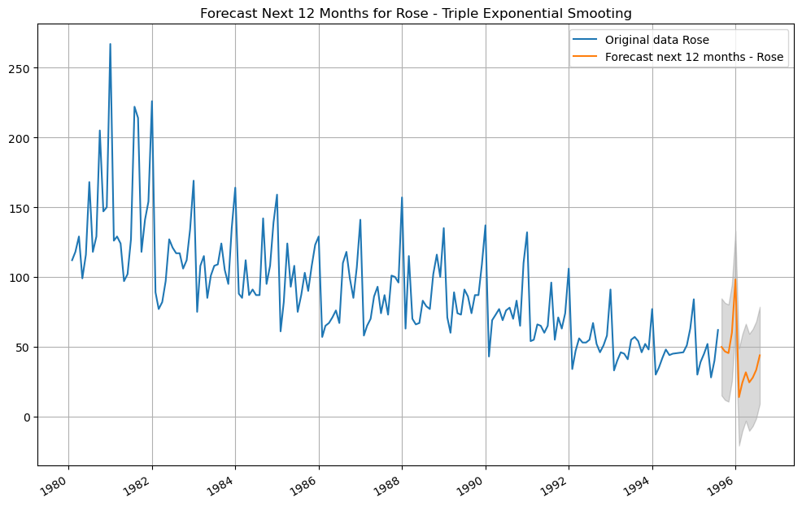

Figure 66: Rose Wine Forecast - next 12 months - Triple Exponential Smoothing – Additive

**Sparkling Wine:**

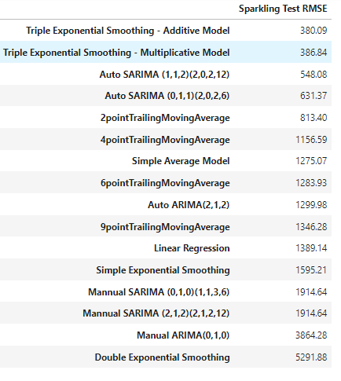

Figure 67: RSME Values of Sparkling Wine in Ascending Order

The Best Model so far is Triple Exponential Smoothing – Additive Model.

**Triple Exponential Smoothing – Additive Model:**

|  |  |
| --- | --- |
| **YearMonth** | **Forecast** |
| 31-08-1995 | 1877.432 |
| 30-09-1995 | 2405.285 |
| 31-10-1995 | 3242.105 |
| 30-11-1995 | 3922.189 |
| 31-12-1995 | 6118.502 |
| 31-01-1996 | 1262.619 |
| 29-02-1996 | 1592.138 |
| 31-03-1996 | 1831.653 |
| 30-04-1996 | 1806.47 |
| 31-05-1996 | 1651.723 |
| 30-06-1996 | 1586.507 |
| 31-07-1996 | 1977.014 |

Table 3: Sparkling Wine Forecast - next 12 months - Triple Exponential Smoothing – Additive

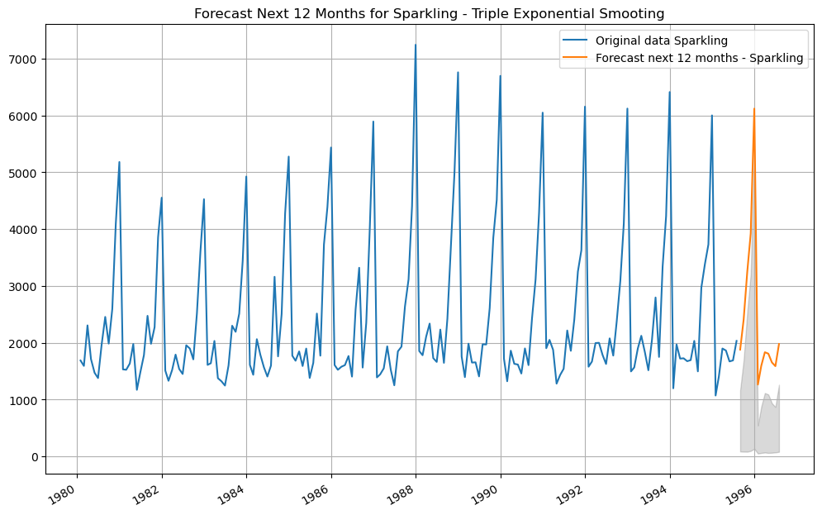

Figure 68: Sparkling Wine Forecast - next 12 months - Triple Exponential Smoothing – Additive

**Actionable Insights & Recommendations:**

**Rose Wine - Comments:**

* Sales of rose wine have steadily declined since 1980.
* This indicates a drop in popularity of this wine variety.
* Sales typically increase in the fourth quarter of the year (October-December).
  + This might be due to the Holiday season in this period.
  + Highest peak in sales is seen in Dec every year.
* Sales experience a sharp decline in the first quarter of each year beginning in January.
  + This might be due to the after effect or hangover of Holidays.
  + Sales slowly pick up only after May-June.

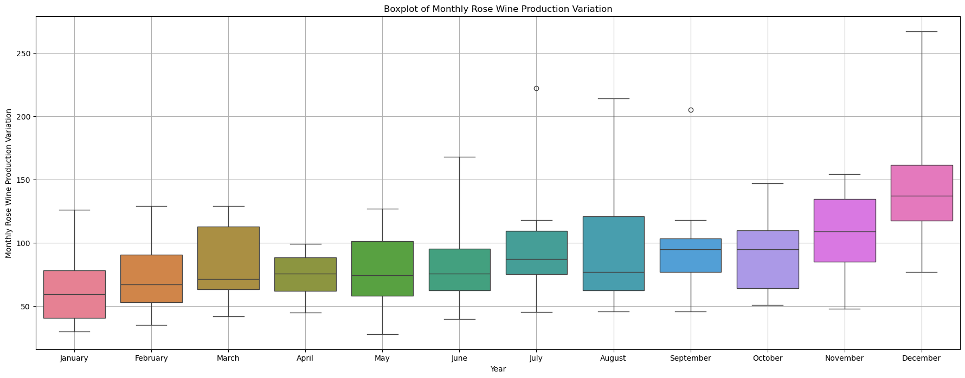

Figure 69: Monthly Sales of Rose Wine

**Rose Wine Sales - Forecast Models:**

* Top 2 best models as per lowest Test RMSE were found to be,
  + 2 Pt Moving Average
  + Triple Exponential Smoothing (Holt-Winters) - Additive Model
* When utilized for forecasting, the 2-point moving average approach does not appear to produce accurate forecasts. After a few repetitions, the forecast values level out.
* Triple Exponential Smoothing (Holt-Winters), appears to provide a forecast that is consistent with the data. Therefore, we have decided to use Holt-Winters for our final Rose Wine Sales prediction.

**Rose Wine Sales - Suggestions:**

* To start with, the holiday season is quickly approaching, and sales are expected to rise, peaking sharply in December. Thus, the company need to restock.
* However, a longer period of time and more data analysis should be done to look at declining rose wine sales.
* Company can rebrand its Rose variant along-with a new Wine-master.
* The business should launch aggressive deals and advertising efforts to capitalize on the impending rise from August to October.
* This will entice first time Wine drinkers and fence sitters (who don’t have specific loyalties to any particular brand).
* Should sales not show a discernible increase trend by December, the company's options are as follows: either engage in research and development, or consider terminating current variant and developing a whole new product.

**Sparkling Wine - Comments:**

* Sparkling wine sales don’t show any upward or downward trend,
  + This shows flat sales over long term range.
* Moreover, a sharp increase in sales is observed in the final quarter of each year, from October to December.
  + This might be due to the Holiday season in this period.
  + Highest peak in sales is seen in Dec every year - Dec sales are almost 3 times of Sep sales
* Just like with rose wine, the first quarter of every year from January to March sees an instantaneous, crashing decline in sales, even in sparkling wine.
  + This might be due to the after effect or hangover of Holidays.
* Sales only gradually increase from July to August.

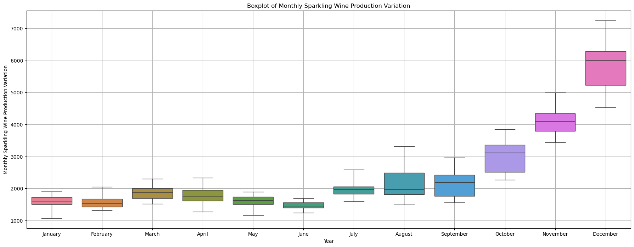

Figure 70: Monthly Sales of Sparkling Wine

**Sparkling Wine Sales - Forecast Models:**

* Triple Exponential Smoothing (Holt-Winters) Models perform the best on Sparkling dataset, considering the least RMSE on Test data.
* Finally, for forecast of Sparkling Wine Sales - we choose Triple Exponential Smoothing (Holt-Winters) with Additive Seasonality and Additive Damped Trend.

**Sparkling Wine Sales - Suggestions:**

* Even for sparkling, the holiday season is quickly approaching, and sales are expected to rise, peaking sharply in December. Thus, the company should restock.
* Sparkling wine is very popular over the holidays, as seen by its strong sales.
* Ads are advised during the months of October through December, but there's no need to introduce any deals at this time. This will further increase sales.
* Sparkling wines are typically connected to festivities and are primarily meant to pop.
* For bursting, a unique designer bottle might be introduced at a lower cost. Profits will be maximized by this.
* There is no discernible rise or fall in sales year over year.
* Even though holiday sales surges are unusual, more research has to be done on year-over-year sales in general. This in-depth examination should be done in the early part of January.